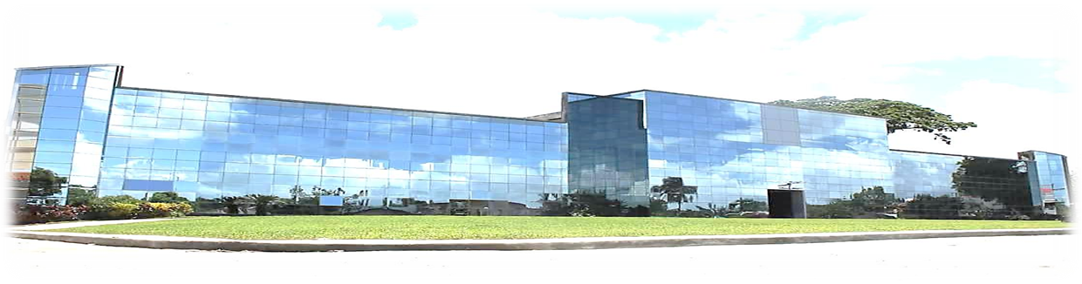
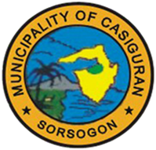
Republic of the Philippines
Province of Sorsogon
MUNICIPALITY OF CASIGURAN

Bid Evaluation Report

PROJECT IDENTIFICATION - for CONSTRUCTION OF A DECORATIVE FENCE AROUND POBLACION, CASIGURAN, SORSOGON.

Table 1. Identification
- Purchaser (or Employer)  - Name  - Address | Local Government Unit-Casiguran
- Name of the Project | - for {{project_title_upper}}
- Location of the Project  - Approved Budget of Contract | Casiguran, Sorsogon  Php {{approved_budget}}
- Method of Procurement | Competitive Bidding

- INITIAL STEPS IN THE BIDDING PROCESS
Initial steps were taken, as enumerated below, to assure a successful bidding process in strict adherence to RA 9184.

Time frame in the pre-bidding stage were then established using the limits set forth by law.

Table 2. Initial Steps in the Bidding Process
- Pre-Procurement Conference  - Date of Conference | N/A
- Invitation to Apply for Eligibility and to Bid  - Date of publication | July 15, 2025
- Eligibility Check  - Date of eligibility check  - Number of eligibility envelopes received | August 4, 2025  One (1)
- Issuance of Bidding Documents  - Period of availability of Bid Docs  - Number of Bid Docs issued | July 15 - August 4, 2025  One (1)
- Pre-bid Conference if any  - Date of Conference | July 22, 2025

- SUBMISSION AND OPENING OF BIDS AND PRELIMINARY EXAMINATION

The Bid Submission and the consequent Bid Opening proceeded as scheduled. There are six (6) bidders purchased Bidding Documents and submitted Bid proposal.

After thorough evaluation of the documents submitted by the bidders, AZLJ CONSTRUCTION complied with all the requirements set forth in the instruction to Bidders previously given to them.

The documents submitted by AZLJ CONSTRUCTION is rated as eligible, the documents submitted were complete and got the Lowest Calculated Bid.

In the presence of the representative of the Bidders, the BAC, the Secretariat and the TWG of the LGU-Casiguran, credibly conducted the Bidding process in full satisfaction of the Bidder. Fairness and transparency were observed with utmost prudence.

Table 3. Bid Submission and Opening
- Bid Submission Deadline  - Original date, time  - Extensions, if any | August 4, 2025, at 8:30 am
- Bid Opening date, time | August 4, 2025, at 10:00am
- Numbers of bids submitted | One (1) Bidding document
- Bid validity period (days or weeks)  - Originally specified  - Extensions/Revisions if any | 120c.d.

Table 4. Bid Price (as Read Out)
Bidder Identification/Name | Bid as Read  Amount (P)
AZLJ CONSTRUCTION | PHP 4,489,974.39

- BID EVALUATION

It appeared that AZLJ CONSTRUCTION submitted the Lowest Calculated Bid, offering the amount of Four Million Four Hundred Eighty-Nine Thousand Nine Hundred Seventy-Four Pesos and 39/100 (PHP 4,489,974.39). Considering that the bidder mentioned above complied and submitted the required documents and in as much as the ABC is Php 4,500,000.00, the BAC proceeded with the Post Qualification process.
Table 5. Correction of Bids
Bidder Identification/Name | Bid as Calculated  Amount (P)
AZLJ CONSTRUCTION | PHP 4,489,974.39

Prepared by: Submitted by:

IRYN L. HABOC JOEL J. RODRIGUEZ
TWG Member BAC Secretariat-Head

